Name:_____________________________ /78

2A2B HUMAN BIOLOGY

**CELL DIVISION, REPRODUCTION AND HORMONAL CONTROL TEST**

Part one – multiple choice

1. Where does fertilisation occur?

a) Uterus

b) Fallopian tube (oviduct)

c) Ovary

d) Vagina

2. What is the function of cilia in the fallopian tube?

a) To provide nutrients for the ova.

b) To produce ova.

c) To lubricate the fallopian tube.

d) To guide ova along the fallopian tube.

3. Why is the endometrium shed at the end of the menstrual cycle?

a) The ova has implanted in the uterus.

b) It is no longer needed because no fertilised egg is going to be implanted.

c) No egg has been released during ovulation.

d) The lining becomes too full of blood and heavy.

4. What is the function of the testes?

a) Produces testosterone and spermatozoa.

b) Makes sperm and oestrogen.

c) Allows sperm to mature before moving into the vas deferens.

d) Produces luteinising hormone and testosterone.

5. Which of the following is **not** true?

a) The male gamete is spermatozoa.

b) The female gonad is the ovary.

c) Gametes are diploid.

d) Gametes are sex cells.

6. Menarche is the

a) end of the fertile period in women

b) onset of puberty in girls

c) onset of menstruation in girls

d) rapid growth at puberty

7 Which of the following hormones causes development of secondary sexual characteristics in males?

a) follicle stimulating hormone

b) oestrogen

c) testosterone

d) luteinizing hormone

8. The ovarian follicle secretes the hormone:

a) oestrogen

b) follicle stimulating hormone

c) progesterone

d) luteinizing hormone

9. The following are events leading to menstruation. Which is the PRIMARY event which sets the others in motion?

a) degeneration of the blood supply to the endometrium

b) degeneration or the corpus luteum

c) reduction in the blood concentrations or oestrogen and progesterone

d) reduction in the supply of Luteinising Hormone

10. Menopause is the

a) end of the fertile period in women

b) onset of puberty in girls

c) onset of menstruation in girls

d) rapid growth at puberty

11. Where does insemination occur?

a) Uterus

b) Fallopian tube (oviduct)

c) Ovary

d) Vagina

Part two – short answer

1. What secondary sexual characteristics would a physically mature adolescent show?

List 3 for males and 3 for females. (6 marks)

|  |  |
| --- | --- |
| Males | Females |
|  |  |

1. Compare spermatogenesis and oogenesis, listing similarities and differences. (4 marks)

_____________________________________________________________________________________________________________________________________________________________________________________________________________________________________________________________________________________________________________________________________________________________________________________________________________________________________________________________________________________________________________________________________________________________________________________________________________________________________________________________________________________________________________________________________________________________________________________________________________________

3. Complete the table below. (12 marks)

|  |  |  |
| --- | --- | --- |
|  | Mitosis | Meiosis |
| The type of cells this occurs in |  |  |
| Function of process |  |  |
| The number of daughter cells that are produced |  |  |
| The number of divisions |  |  |
| Are the daughter cells genetically identical to the parent cells? |  |  |
| The number of chromosomes in each cell  produced |  |  |

4. Fill in the table below which shows the phases of mitosis. (12 marks)

|  |  |  |
| --- | --- | --- |
| Phase of mitosis | **Describe** what is happening | Diagram |
|  |  |  |
|  |  |  |
|  |  |  |
|  |  |  |

5. There is of cell division occurring at the end mitosis not shown in the table. (3 marks)

A What is it? ________________________________________________________________________________________

B What happens during this phase? __________________________________________________________________________________________________________________________________________________________________________________________________________________________________

C Why is it not included in Mitosis? __________________________________________________________________________________________________________________________________________________________________________________________________________________________________

6. **Label** the diagrams below. (9 marks)

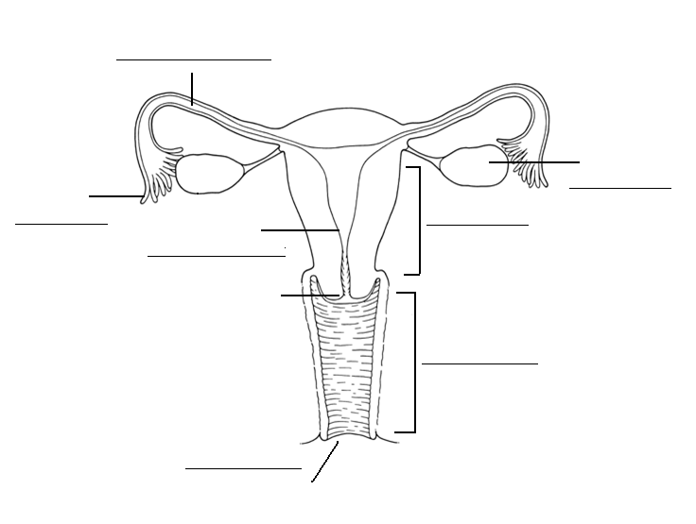

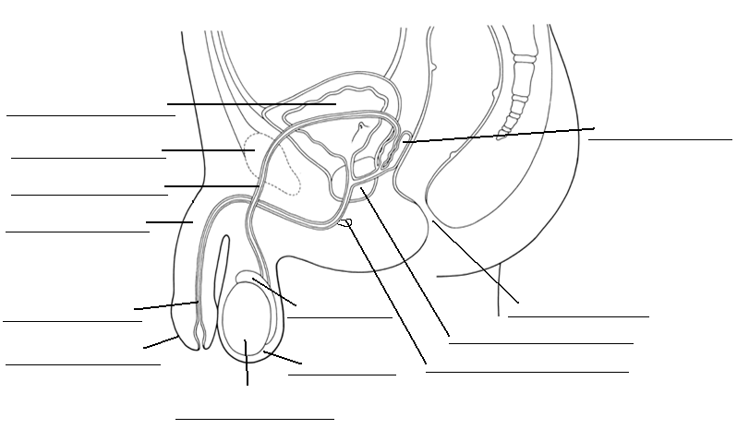

Use the diagram below to answer the following questions.

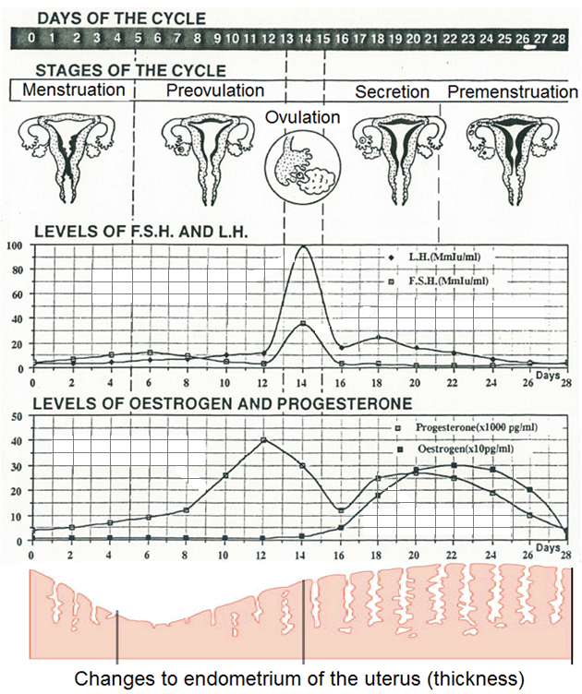7. Why does L.H peak when it does? (1 mark)

__________________________________________________________________________________________________________________________________________________________________________________________________________________________________

8. A Locate the corpus luteum on the diagram above. (1 mark)

B What is the function of the corpus luteum? (1 mark)

__________________________________________________________________________________________________________________________________________________________________________________________________________________________________

9. Why is the secretion phase called the secretion phase? (1 mark)

__________________________________________________________________________________________________________________________________________________________________________________________________________________________________

10. Fill in the table below. (7 marks)

|  |  |  |  |
| --- | --- | --- | --- |
|  | Where is it secreted from | Target organ | Effect of hormone |
| FSH |  |  | **⮚**  **⮚** |
| HCG |  |  | **⮚** |

Part two – extended answer

1. There are a number of steps involved in the production of semen. Starting from the beginning of the end of spermatogenesis, **describe** the steps taken to produce the final ejaculated product. Include the substances added, where they are added from and what their functions are.

(10 marks)

__________________________________________________________________________________________________________________________________________________________________________________________________________________________________________________________________________________________________________________________________________________________________________________________________________________________________________________________________________________________________________________________________________________________________________________________________________________________________________________________________________________________________________________________________________________________________________________________________________________________________________________________________________________________________________________________________________________________________________________________________________________________________________________________________________________________________________________________________________________________________________________________________________________________________________________________________________________________________________________________________________________________________________________________________________________________________________________________________________________________________________________________________________________________________________________________________________________________________________________________________________________________________________________________________________________________________________________________________________________________________________________________________________________________________________________________________________________________________________________________________________________________________________________________________________________________________________________________________________________________________________________________________________________________________________________________________________________________________________________________________________________________________________________________________________________________________________________________________________________________________________________________________________________________________________________________________________________________________________________________________________________________________________________________________________________________________________________________________________________________________________________________________________________________________________________________________________________________________________________________________________________________________________________________________________________________________________________________________________________________________________________________________________________________________________________________________________________________________________________________________________________________________________________________________________________________________________________________________________________________________________________________________________________________________________________________________________________________________________________________________________________________________________________________________________________________________________________________________________________________________________________________________________________________________________________________________________________________________________________________________________________________________________________________________________________________________________________________________________________________________________________________________________________________________

Name:_____________________________ /78

2A2B HUMAN BIOLOGY

**CELL DIVISION, REPRODUCTION AND HORMONAL CONTROL TEST**

Part one – multiple choice

1. Where does fertilisation occur?

a) Uterus

b) Fallopian tube (oviduct)

c) Ovary

d) Vagina

2. What is the function of cilia in the fallopian tube?

a) To provide nutrients for the ova.

b) To produce ova.

c) To lubricate the fallopian tube.

d) To guide ova along the fallopian tube.

3. Why is the endometrium shed at the end of the menstrual cycle?

a) The ova has implanted in the uterus.

b) It is no longer needed because no fertilised egg is going to be implanted.

c) No egg has been released during ovulation.

d) The lining becomes too full of blood and heavy.

4. What is the function of the testes?

a) Produces testosterone and spermatozoa.

b) Makes sperm and oestrogen.

c) Allows sperm to mature before moving into the vas deferens.

d) Produces luteinising hormone and testosterone.

5. Which of the following is **not** true?

a) The male gamete is spermatozoa.

b) The female gonad is the ovary.

c) Gametes are diploid.

d) Gametes are sex cells.

6. Menarche is the

a) end of the fertile period in women

b) onset of puberty in girls

c) onset of menstruation in girls

d) rapid growth at puberty

7 Which of the following hormones causes development of secondary sexual characteristics in males?

a) follicle stimulating hormone

b) oestrogen

c) testosterone

d) luteinizing hormone

8. The ovarian follicle secretes the hormone:

a) oestrogen

b) follicle stimulating hormone

c) progesterone

d) luteinizing hormone

9. The following are events leading to menstruation. Which is the PRIMARY event which sets the others in motion?

a) degeneration of the blood supply to the endometrium

b) degeneration or the corpus luteum

c) reduction in the blood concentrations or oestrogen and progesterone

d) reduction in the supply of Luteinising Hormone

10. Menopause is the

a) end of the fertile period in women

b) onset of puberty in girls

c) onset of menstruation in girls

d) rapid growth at puberty

11. Where does insemination occur?

a) Uterus

b) Fallopian tube (oviduct)

c) Ovary

d) Vagina

Part two – short answer

1. What secondary sexual characteristics would a physically mature adolescent show?

List 3 for males and 3 for females. (6 marks)

|  |  |
| --- | --- |
| Males | Females |
| Enlargement of Penis, scrotum, prostate  Growth of pubic, facial, underarm, chest hair  Shoulders broaden  Deeper voice – enlarged larynx  Increased perspiration  Oil production | Breasts  Hips widening  Deposition of fat leading to curved shape  Growth of pubic, underarm hair  Oil production |

1. Compare spermatogenesis and oogenesis, listing similarities and differences. (4 marks)

|  |  |
| --- | --- |
| Spermatogenesis | Oogenesis |
| * 4 gametes * Begins at puberty * Leaves behind one cell to undergo the process again * Occurs in males | * 1 gamete * Begins before birth then pauses at prophase * Does not leave behind another cell to produce new cells * Occurs in females |

3. Complete the table below. (12 marks)

|  |  |  |
| --- | --- | --- |
|  | Mitosis | Meiosis |
| The type of cells this occurs in | General Body Cells | Sex Cells / Gametes |
| Function of process | Growth and Repair | Production of Gametes |
| The number of daughter cells that are produced | 2 | 4 |
| The number of divisions | 1 | 2 |
| Are the daughter cells genetically identical to the parent cells? | Yes | No |
| The number of chromosomes in each cell  produced | 46 | 23 |

4. Fill in the table below which shows the phases of mitosis. (12 marks)

|  |  |  |
| --- | --- | --- |
| Phase of mitosis | **Describe** what is happening | Diagram |
| Prophase  1 | Nucleoli disappear  Nuclear membrane breaks down  Centrioles move towards opposite ends  Chromosomes appear as pairs  Spindle fibres form  ANY TWO |  |
| Metaphase  1 | Chromosomes line up along equator  1  Join spindles  1 |  |
| Anaphase  1 | Centromeres divide  1  Chromosomes move to opposite ends of spindle  1 |  |
| Telophase  1 | Spindle disappears  Nuclear membrane form  Nucleoli form  Centrioles divide  Chromosomes uncoil and disappear  ANY TWO |  |

5. There is of cell division occurring at the end mitosis not shown in the table. (3 marks)

A What is it? _Cytokinesis (1 mark)

B What happens during this phase? Cytoplasm divides (1 mark)

C Why is it not included in Mitosis? Mitosis occurs with the genetic information inside the nucleus and does not include the process that occurs in the rest of the cell (1 mark)

6. **Label** the diagrams below. (9 marks)



Bladder

Pubic Bone Seminal Vesicle

Vas Deferens

Penis

Urethra Epididymis Anus

Not labelling glands Scrotum Prostate

Bulbo Urethral Gland

Testes

Fallopian Tube

Ovary

Fimbrae Endometrium Uterus

Cervix Vagina

Use the diagram below to answer the following questions.

7. Why does L.H peak when it does? (1 mark)

Released by the pituitary to promote Ovulation and formation of Corpus Luteum

Must mention both Ovulation and CL for mark

8. A Locate the corpus luteum on the diagram above. (1 mark)

B What is the function of the corpus luteum? (1 mark)

Produce progesterone and oestrogen and delay menstruation

9. Why is the secretion phase called the secretion phase? (1 mark)

As watery mucus is secreted by endometrium, cervix and fallopian tubes.

10. Fill in the table below. (7 marks)

|  |  |  |  |
| --- | --- | --- | --- |
|  | Where is it secreted from | Target organ | Effect of hormone |
| FSH | Pituitary Gland  1 | Seminiferous tubules and follicles of ovaries  Must mention both for mark  1 | ⮚production of sperm  ⮚maturation of ovarian follicles |
| HCG | Placenta  1 | Corpus luteum  1 | ⮚Maintenance of corpus luteum during early stages of pregnancy  1 |

Part two – extended answer

1. There are a number of steps involved in the production of semen. Starting from the beginning of the end of spermatogenesis, **describe** the steps taken to produce the final ejaculated product. Include the substances added, where they are added from and what their functions are.

(10 marks)

Sperm is produces in testes and stored in epididymis

Seminal vesicle secretes fluid

Which is rich in sugars

to give nutrients to sperm

Prostate gland

Secretes thin milky alkaline fluid

to activate sperm/ combat acidic vagina

Bulbo urethral gland

Secretes

clear mucus that

acts as lubricant

1 mark each point